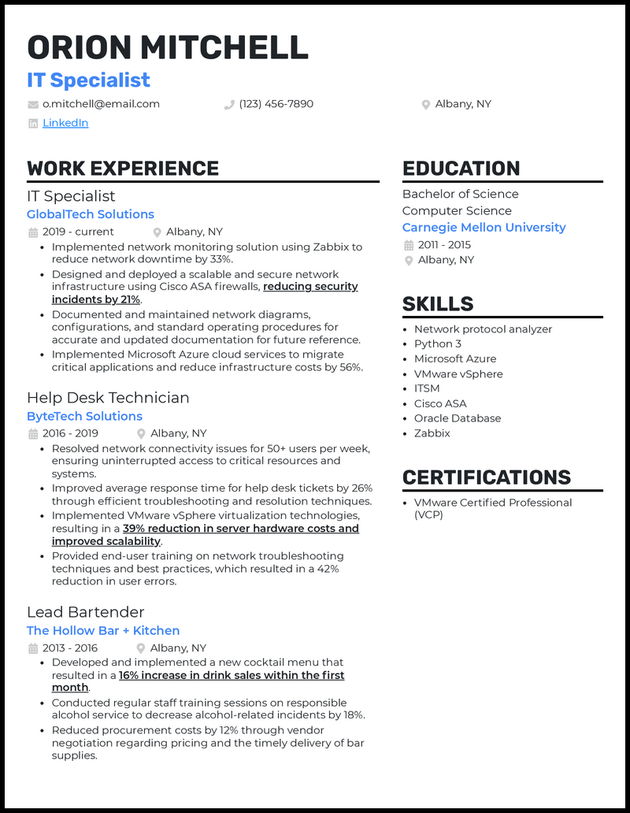
ORION MITCHELL
IT Specialist
o.mitchell@email.com
in LinkedIn
WORK EXPERIENCE
IT Specialist
GlobalTech Solutions
.
.
2019 - current
Albany, NY
(123) 456-7890
Albany, NY
Implemented network monitoring solution using Zabbix to reduce network downtime by 33%.
Designed and deployed a scalable and secure network infrastructure using Cisco ASA firewalls, reducing security incidents by 21%.
Documented and maintained network diagrams, configurations, and standard operating procedures for accurate and updated documentation for future reference. Implemented Microsoft Azure cloud services to migrate critical applications and reduce infrastructure costs by 56%.
Help Desk Technician ByteTech Solutions
2016-2019
Albany, NY
• Resolved network connectivity issues for 50+ users per week, ensuring uninterrupted access to critical resources and systems.
• Improved average response time for help desk tickets by 26% through efficient troubleshooting and resolution techniques. Implemented VMware vSphere virtualization technologies, resulting in a 39% reduction in server hardware costs and improved scalability.
.
• Provided end-user training on network troubleshooting techniques and best practices, which resulted in a 42% reduction in user errors.
Lead Bartender
The Hollow Bar + Kitchen
2013-2016
Albany, NY
• Developed and implemented a new cocktail menu that resulted in a 16% increase in drink sales within the first month.
• Conducted regular staff training sessions on responsible alcohol service to decrease alcohol-related incidents by 18%.
•
Reduced procurement costs by 12% through vendor negotiation regarding pricing and the timely delivery of bar supplies.
EDUCATION
Bachelor of Science Computer Science
Carnegie Mellon University 2011-2015 Albany, NY
SKILLS
• Network protocol analyzer • Python 3
• Microsoft Azure • VMware vSphere • ITSM
• Cisco ASA
• Oracle Database
• Zabbix
CERTIFICATIONS
VMware Certified Professional (VCP)

